Mini Verify.gov.kh Concept Using Hash + QR Code

1. Lab objective
Students will understand:
- What document verification means
- What a hash is
- Why changing one word changes the hash
- How QR Code helps users verify a document
- How blockchain can store a trusted hash record

2. Lab concept
Use this diagram on the whiteboard:
Teacher creates certificate
↓
System generates document hash
↓
Hash is stored as trusted record
↓
QR code points to verification page
↓
Student scans QR code
↓
System checks the trusted record
↓
Result: Valid or Invalid

3. Tools needed
For easy classroom demo, use Python.
Install these:
pip install flask qrcode pillow
You can do this on:
- Windows
- Kali Linux
- Ubuntu
- macOS

4. Create project folder
- Create one folder:
mkdir mini_verify_lab
cd mini_verify_lab
- Inside this folder, create this structure:

- mini_verify_lab/
│
├── app.py
├── certificates/
│ └── certificate_001.txt
└── static/
Create folders:
mkdir certificates
mkdir static

5. Create sample certificate
Create file:
nano certificates/certificate_001.txt
Put this inside:
SEYHA CYBER ACADEMY
Certificate ID: CERT-001
Student Name: Dara Sok
Course: Blockchain Technology
Date: 28 June 2026
Result: Completed
Issued by: Seyha Cyber Academy
Save it.
This is your original trusted certificate.

6. Create the verification system
Create file:
nano app.py
Paste this code:
from flask import Flask, request
import hashlib
import qrcode
import os
app = Flask(__name__)
CERT_FILE = "certificates/certificate_001.txt"
CERT_ID = "CERT-001"
# This simulates a blockchain/trusted record
trusted_records = {}
def calculate_hash(file_path):
with open(file_path, "rb") as file:
file_data = file.read()
sha256_hash = hashlib.sha256(file_data).hexdigest()
return sha256_hash
@app.route("/")
def home():
return """
<h2>Mini Verify.gov.kh Classroom Lab</h2>
<p>This is a safe demo for learning document verification using Hash + QR Code.</p>
<p><a href="/issue">Step 1: Issue Certificate</a></p>
<p><a href="/verify?cert_id=CERT-001">Step 2: Verify Certificate</a></p>
"""
@app.route("/issue")
def issue_certificate():
cert_hash = calculate_hash(CERT_FILE)
# Store hash in trusted record
trusted_records[CERT_ID] = cert_hash
# Create QR code
verify_url = f"http://127.0.0.1:5000/verify?cert_id={CERT_ID}"
qr = qrcode.make(verify_url)
qr_path = os.path.join("static", "certificate_qr.png")
qr.save(qr_path)
return f"""
<h2>Certificate Issued Successfully</h2>
<p><b>Certificate ID:</b> {CERT_ID}</p>
<p><b>Trusted SHA-256 Hash:</b></p>
<p>{cert_hash}</p>
<p>This hash is now stored as the trusted record.</p>
<h3>QR Code</h3>
<img src="/static/certificate_qr.png" width="200">
<p><a href="/verify?cert_id={CERT_ID}">Verify Certificate</a></p>
"""
@app.route("/verify")
def verify_certificate():
cert_id = request.args.get("cert_id")
if cert_id not in trusted_records:
return """
<h2 style='color:red;'>Invalid Certificate</h2>
<p>This certificate ID was not found in the trusted record.</p>
"""
current_hash = calculate_hash(CERT_FILE)
trusted_hash = trusted_records[cert_id]
if current_hash == trusted_hash:
return f"""
<h2 style='color:green;'>Certificate is VALID</h2>
<p>The certificate matches the trusted record.</p>
<p><b>Certificate ID:</b> {cert_id}</p>
<p><b>Current Hash:</b></p>
<p>{current_hash}</p>
"""
else:
return f"""
<h2 style='color:red;'>Certificate is INVALID</h2>
<p>The certificate was changed or does not match the trusted record.</p>
<p><b>Trusted Hash:</b></p>
<p>{trusted_hash}</p>
<p><b>Current Hash:</b></p>
<p>{current_hash}</p>
"""
if __name__ == "__main__":
app.run(debug=True)

7. Run the lab
Run:
python app.py
Open browser:
http://127.0.0.1:5000
Click:
Step 1: Issue Certificate
Now the system will:
- Read the certificate
- Generate SHA-256 hash
- Store the hash as trusted record
- Generate QR code
Then click:
Verify Certificate
You should see:
Certificate is VALID

8. Test tampering
Now change the certificate.
Open:
nano certificates/certificate_001.txt
Change:
Student Name: Dara Sok
to:
Student Name: Fake Student
Save it.
Now refresh the verify page:
http://127.0.0.1:5000/verify?cert_id=CERT-001
You should see:
Certificate is INVALID
Explain to students:
“Only one word changed, but the hash became totally different. This is why hash is useful for document integrity.”

9. Classroom activity plan

Time: 60–90 minutes

Part 1: Teacher explanation — 10 minutes
Explain:
Document → Hash → Trusted Record → QR Code → Verification
Teacher sentence:
“A hash is like a digital fingerprint of a document.”

2. Create project folder
mrseyhapheav@cloudshell:~$ mkdir mini_verify_lab
mrseyhapheav@cloudshell:~$ cd mini_verify_lab
mrseyhapheav@cloudshell:~/mini_verify_lab$

3. Create Python virtual environment
mrseyhapheav@cloudshell:~$ python3 -m venv venv
mrseyhapheav@cloudshell:~$ source venv/bin/activate
(venv) mrseyhapheav@cloudshell:~$
4. Install tools
mrseyhapheav@cloudshell:~$ pip install flask qrcode pillow
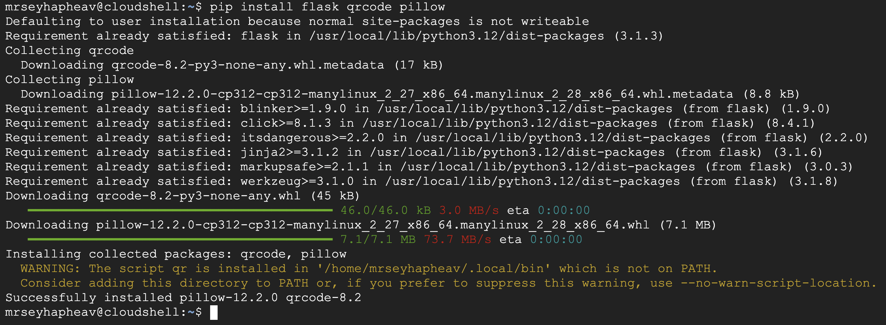
5. Create folders and files
mkdir certificates
mkdir static
touch app.py
result :
mrseyhapheav@cloudshell:~/mini_verify_lab$ mkdir certificates
mrseyhapheav@cloudshell:~/mini_verify_lab$ mkdir static
mrseyhapheav@cloudshell:~/mini_verify_lab$ touch app.py
mrseyhapheav@cloudshell:~/mini_verify_lab$ ls
app.py certificates static
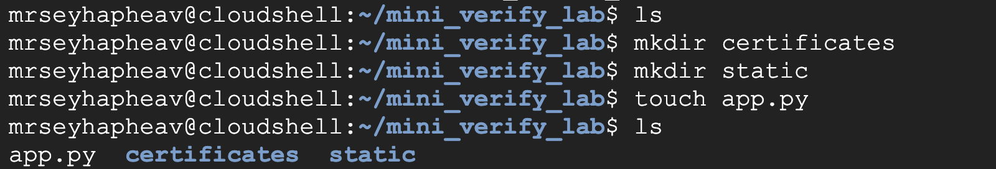
6. Create certificate file
Paste this:
SEYHA CYBER ACADEMY
Certificate ID: CERT-001
Student Name: Dara Sok
Course: Blockchain Technology
Date: 28 June 2026
Result: Completed
Issued by: Seyha Cyber Academy
Save:
Ctrl + O
Enter
Ctrl + X

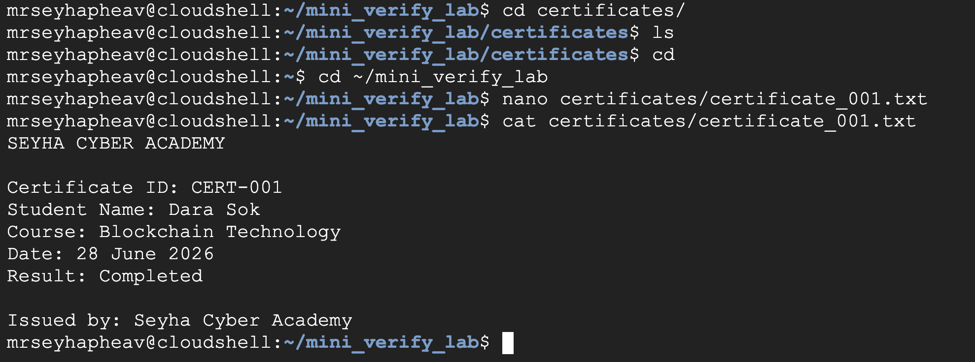

7. Run the lab
Run:
python app.py
Open browser:
http://127.0.0.1:5000
Click:
Step 1: Issue Certificate
Now the system will:
- Read the certificate
- Generate SHA-256 hash
- Store the hash as trusted record
- Generate QR code
Then click:
Verify Certificate
You should see:
Certificate is VALID

